Architecture
Evaluation Environment
Cached
Mini-LLM
CLIP Encoder
Data
Caption parquet from LLM” (or “LLM-generated caption parquet”
PPO Policy
VecNormalize
Rendered Frame
Training
Loop

Checkpoint
Monitor
LLM/ OpenAI


TensorBoard

Data (captions parquet)
- We built cached_llm/embeddings_batch_*.parquet.
- Each row has: (episode_id, step, text, embedding).
- Those text embeddings are precomputed (no API needed) with a local SBERT model (all-MiniLM-L6-v2).
- Why we do this offline: it removes any LLM latency/cost during RL and keeps the RL loop deterministic.

CLIP Encoder (vision stream, online)
- At every environment step the wrapper renders an RGB frame (render_mode="rgb_array").
- The CLIP image encoder (e.g., openai/clip-vit-base-patch32) turns that frame into a fixed-dim vector.
- Output: z_img ∈ R^Dclip (e.g., 512 or 768 depending on the model head).

Cached “Mini-LLM” (language stream, offline)
- In the wrapper we load your cached parquet(s) via CachedLLMEmbedder.
- For the current (episode_id, step) we fetch the precomputed text embedding of the caption (or nearest available step).
- Output: z_txt ∈ R^Dtext (for all-MiniLM-L6-v2, D=384 when normalized).

Training Loop (feature fusion → PPO)
- The custom SB3 features extractor (CLIPLangExtractor) receives both z_img and z_txt from the wrapper’s observation dict.
- It concatenates / linearly projects them into a single latent z = f([z_img, z_txt]) with size features_dim (e.g., 512).
- PPO’s policy (π) and value (V) MLPs (e.g., [256,256]) operate on z to:
  - Choose an action (accel, brake, lane change…)
  - Estimate value for GAE/advantage updates
- The standard PPO loop runs:
  - Collect rollouts for n_steps in env(s), storing obs, actions, rewards, dones.
  - Compute advantages (GAE) and returns.
  - Optimize policy/value with clipped surrogate loss (monitoring approx_kl, clip_fraction, value_loss, etc.).
  - Log to TensorBoard through SB3.

Environment plumbing (on-policy but stabilized)
- VecNormalize: normalizes observations/rewards online to stabilize PPO.
- Monitor: records episode stats (ep_len_mean, ep_rew_mean) for clean logs.
- TensorBoard: visualizes rollout/*, train/*, eval/*, time/*.
- Checkpoint: periodic snapshots (ckpt/ppo_*.zip) + a best model via EvalCallback.
In your project this is wired in train_ppo_clip_standalone.py:
- VecNormalize and VecMonitor wrap the envs
- EvalCallback runs a separate eval env every N steps
- CheckpointCallback saves periodic models
- Logs go to runs/ppo_ambulance/seed_<N>/

Evaluation Environment (separate, clean)
- A second env (same config but eval_env.training=False) runs N episodes periodically:
  - Computes eval/mean_reward, eval/mean_ep_length
  - Saves best model to runs/ppo_ambulance/seed_<N>/best/
- We also sync VecNormalize stats from train → eval so scaling matches.

Cars open the road” (behavioral realism)
- Your YieldingIDM class (in rl_langvision/yielding_traffic.py) modifies non-ego vehicles when env.config["is_emergency"]=True:
  - If ego ambulance is within a radius (e.g., 60 m), they:
    - increase time headway (more spacing),
    - reduce target speed (create gaps),
    - bias lane change to the right (or shoulder) to make way.

What is learned
- The policy learns to exploit visual cues (from CLIP) + linguistic priors (from captions) to:
  - choose speed and lane changes that keep the ambulance safe,
  - leverage the gaps other vehicles create (due to YieldingIDM),
  - optimize your shaped reward (speed/right-lane bonuses, collision penalties, etc.).
RESULT

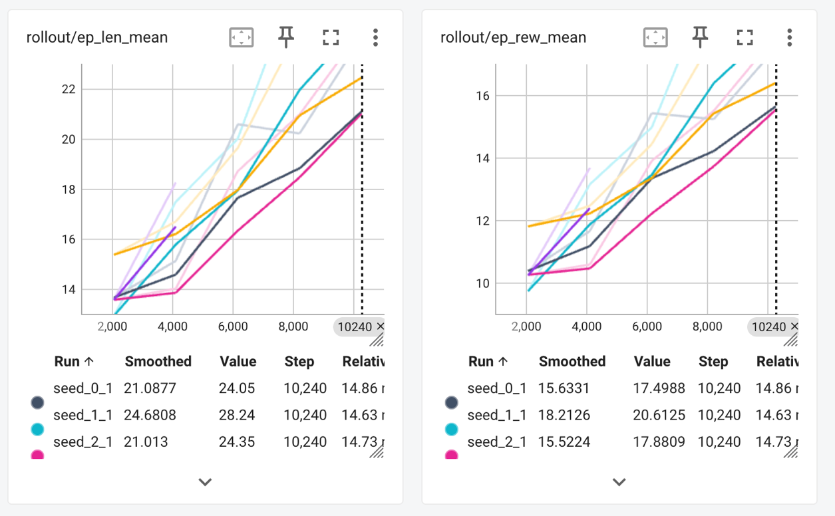

Rollout
- ep_len_mean: climbs from ~13 → 22 steps. Episodes last longer before termination → fewer early crashes/timeouts.
- ep_rew_mean: rises ~10 → 17. Reward is improving across seeds; nice, steady slope.
Eval
- mean_ep_length ~ 42–50 and mean_reward ~ 28.8–35.2 (depending on seed). Longer eval episodes than rollouts = policy generalizes better in eval (no training noise, deterministic). One seed (magenta) lags but is OK for this horizon.

